**Warranty Claims Fraud Prediction**

The aim of this project is to analyze the warranty claims based on their region, product, claim value and other features to predict their authenticity. The dataset is taken from Kaggle. The dataset contains 358 rows and 21 columns.

# Data Dictionary

**Column Name Description**

Unnamed: 0 Index

|  |  |
| --- | --- |
| Region | Region of the claim |
| State | State of the claim |
| Area | Area of the claim |
| City | City of the claim |
| Consumer_profile | Consumer profile Business/Personal |
| Product_category | Product category Household/Entertainment |
| Product_type | Product type AC/TV |
| AC_1001_Issue | 1 0- No issue / No componenent, 1- repair, 2-replacement |
| AC_1002_Issue | 1 0- No issue / No componenent, 1- repair, 2-replacement |
| AC_1003_Issue | 1 0- No issue / No componenent, 1- repair, 2-replacement |
| TV_2001_Issue | 1 0- No issue / No componenent, 1- repair, 2-replacement |
| TV_2002_Issue | 1 0- No issue / No componenent, 1- repair, 2-replacement |
| TV_2003_Issue | 1 0- No issue / No componenent, 1- repair, 2-replacement |
| Claim_Value | Claim value in INR |
| Service_Center | Service center code |
| Product_Age | Product age in days |
| Purchased_from | Purchased from - Dealer, Manufacturer, Internet |
| Call_details | Call duration |
| Purpose | Purpose of the call |
| Fraud | Fraudulent (1) or Genuine (0) |

|  |
| --- |
| *# Importing the libraries* **import** numpy **as** np **import** matplotlib.pyplot **as** plt **import** pandas **as** pd **import** seaborn **as** sns |

In [ ]:

|  |  |  |
| --- | --- | --- |
| *#Loading the dataset*  df **=** pd**.**read_csv('df_Clean.csv') df**.**head() |  |  |
| **Unnamed:**  **Region State Area**  **0** | **City** | **Consumer_profile Product_categor** |

In [ ]:

Out[ ]:

**0** 0 South Karnataka Urban Bangalore Business Entertainmen

|  |  |  |  |  |  |  |  |
| --- | --- | --- | --- | --- | --- | --- | --- |
| **1** | 1 | South | Karnataka | Rural | Bangalore | Business | Househo |
| **2** | 2 | North | Haryana | Urban | Chandigarh | Personal | Househo |
| **3** | 3 | South | Tamil  Nadu | Urban | Chennai | Business | Entertainmen |
| **4** | 4 | North East | Jharkhand | Rural | Ranchi | Personal | Entertainmen |

5 rows × 21 columns

# Data Preprocessing Part 1

In [ ]: *# checking the shape of the dataset* df**.**shape

|  |  |
| --- | --- |
| Out[ ]: | (358, 21) |

In [ ]: *# Drop index column* df**.**drop(['Unnamed: 0'], axis**=**1, inplace**=True**)

In [ ]: *# Checking for null/missing values* df**.**isnull()**.**sum()

|  |  |
| --- | --- |
| Out[ ]: | Region 0 |

State 0

Area 0

City 0

Consumer_profile 0

Product_category 0

Product_type 0

AC_1001_Issue 0

AC_1002_Issue 0

AC_1003_Issue 0

TV_2001_Issue 0

TV_2002_Issue 0

TV_2003_Issue 0

Claim_Value 0

Service_Centre 0

Product_Age 0

Purchased_from 0

Call_details 0

Purpose 0

Fraud 0 dtype: int64

In [ ]: *# Checking for duplicate values* df**.**duplicated()**.**sum()

|  |  |
| --- | --- |
| Out[ ]: | 0 |

In [ ]: *# Checking the data types* df**.**dtypes

Out[ ]: Region object State object

Area object

City object

Consumer_profile object

Product_category object

Product_type object

AC_1001_Issue int64

AC_1002_Issue int64

AC_1003_Issue int64

TV_2001_Issue int64

TV_2002_Issue int64

TV_2003_Issue int64

Claim_Value float64

Service_Centre int64

Product_Age int64

Purchased_from object

Call_details float64

Purpose object Fraud int64 dtype: object

In [ ]: *# Unique values in each column* df**.**nunique()

Out[ ]: Region 8

State 20

Area 2

City 27

Consumer_profile 2

Product_category 2

Product_type 2

AC_1001_Issue 3

AC_1002_Issue 3

AC_1003_Issue 3

TV_2001_Issue 3

TV_2002_Issue 3

TV_2003_Issue 3

Claim_Value 107

Service_Centre 7

Product_Age 188

Purchased_from 3

Call_details 37

Purpose 3

Fraud 2

dtype: int64

In [ ]: *# renaming the values in product issue column* df['AC_1001_Issue'] **=** df['AC_1001_Issue']**.**map({ 0 : 'No Issue', 1 : 'repair', 2 df['AC_1002_Issue'] **=** df['AC_1002_Issue']**.**map({ 0 : 'No Issue', 1 : 'repair', 2 df['AC_1003_Issue'] **=** df['AC_1003_Issue']**.**map({ 0 : 'No Issue', 1 : 'repair', 2

|  |  |  |  |  |  |  |  |  |
| --- | --- | --- | --- | --- | --- | --- | --- | --- |
| df['TV_2001_Issue'] df['TV_2002_Issue'] df['TV_2003_Issue'] | **=**  **=**  **=** | df['TV_2001_Issue']**.**map({ df['TV_2002_Issue']**.**map({ df['TV_2003_Issue']**.**map({ | 0  0  0 | :  :  : | 'No Issue',  'No Issue',  'No Issue', | 1  1  1 | :  :  : | 'repair', 2  'repair', 2  'repair', 2 |
| **Descriptive Statistics** | | |  |  |  |  |  |  |
| df**.**describe() | | |  |  |  |  |  |  |

In [ ]:

Out[ ]: **Claim_Value Service_Centre Product_Age Call_details Fraud**

**count** 358.000000 358.000000 358.000000 358.000000 358.000000

|  |  |  |  |  |  |
| --- | --- | --- | --- | --- | --- |
| **mean** | 11994.534916 | 12.812849 | 201.843575 | 11.931844 | 0.097765 |
| **std** | 12063.213579 | 1.766844 | 259.731564 | 11.559474 | 0.297413 |
| **min** | 0.000000 | 10.000000 | 3.000000 | 0.500000 | 0.000000 |
| **25%** | 4006.000000 | 12.000000 | 14.000000 | 1.600000 | 0.000000 |
| **50%** | 7194.000000 | 13.000000 | 60.000000 | 6.500000 | 0.000000 |
| **75%** | 15000.000000 | 15.000000 | 303.750000 | 23.000000 | 0.000000 |
| **max** | 50000.000000 | 16.000000 | 991.000000 | 30.000000 | 1.000000 |

|  |  |  |  |  |  |
| --- | --- | --- | --- | --- | --- |
| df**.**head() |  |  |  |  |  |
| **Region** | **State** | **Area** | **City** | **Consumer_profile** | **Product_category Product_** |

In [ ]: Out[ ]:

**0** South Karnataka Urban Bangalore Business Entertainment

|  |  |  |  |  |  |  |  |
| --- | --- | --- | --- | --- | --- | --- | --- |
| **1** | South | Karnataka | Rural | Bangalore |  | Business | Household |
| **2** | North | Haryana | Urban | Chandigarh |  | Personal | Household |
| **3** | South | Tamil  Nadu | Urban | Chennai |  | Business | Entertainment |
| **4** | North East | Jharkhand | Rural | Ranchi |  | Personal | Entertainment |

# Exploratory Data Analysis

## Location based Distribution of Fraudulent Claims

In [ ]:

|  |
| --- |
| fig, ax **=** plt**.**subplots(2,2,figsize**=**(15,10)) fig**.**subplots_adjust(hspace**=**0.7)  sns**.**histplot(x **=** 'Region', data **=** df, ax **=**ax[0,0], hue **=** 'Fraud', element**=**'bars' ax[0,0]**.**xaxis**.**set_tick_params(rotation**=**90)  sns**.**histplot(x **=** 'State', data **=** df, ax **=**ax[0,1], hue **=** 'Fraud', element**=**'bars' ax[0,1]**.**xaxis**.**set_tick_params(rotation**=**90) sns**.**histplot(x **=** 'City', data **=** df, ax **=**ax[1,0], hue **=** 'Fraud', element**=**'bars', |

,

ax[1,0]**.**xaxis**.**set_tick_params(rotation**=**90) sns**.**histplot(x **=** 'Area', data **=** df, ax **=**ax[1,1], hue **=** 'Fraud', element**=**'bars',

Out[ ]: [Text(0.5, 1.0, 'Areawise Distribution of Fraudulent Claims')]

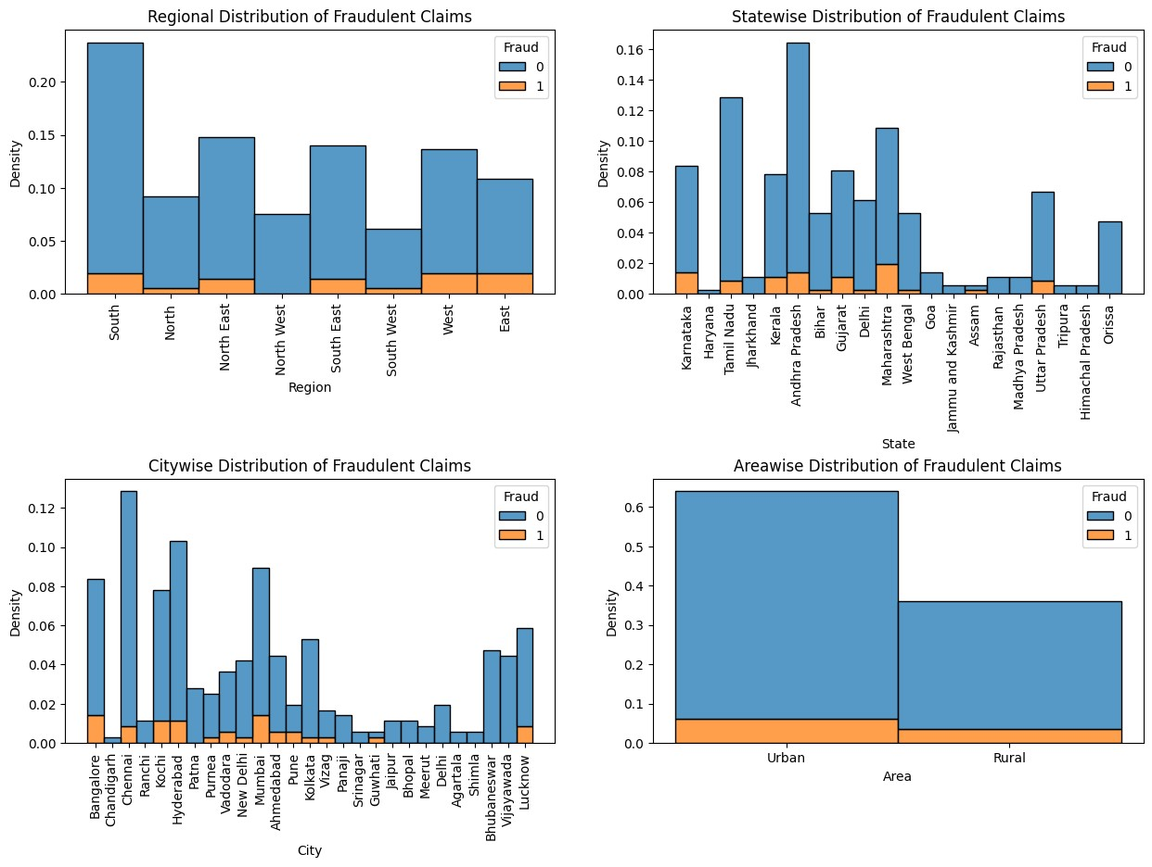

The above plots visualizes the distribution of fraudulent claims based on location. The first graphs shpws the regional distribution of the fraudent claims, where South, North East and south East are among the regionas with highest warranty claims. However, the regions - West, East and South are among regions with highest fraudulent claims.

Interestingly the North West region has zero fraudent claims.

The second graph shows the distribution of fraudulent claims based on the States, where the states - Andhra Pradesh, Maharashtra, Tamil Nadu, Karnataka and Gujarat are among the states with highest number of warranty claims and states - Haryana has lowest warranty claims. The states - Andhra Pradesh, Maharashtra, Tamil Nadu, Karnataka and Gujarat are among the states with highest number of fraudulent claims whereas, states like Bihar, Delhi, West Bengal and Assam are among the states with lowest number of fraudulent claims.

The third graph shows the distribution of fraudulent claims based on cities. The cities Chennai, Hyderabad, Bangalore, Mumbai and Kochi are among the cities with highest claims whereas cities like Chandigarh, Srinagar, Agartala and Shimla have lowest number of claims. Moreover the cities - Chennai, Hyderabad, Bangalore, Mumbai and Kochi are among the cities with highest fraudulent claims whereas cities like Chandigarh, Panaji, Meerut, Jaipur, and many other have zero fraudulent claims.

The forth graph, visualizes the fraudulent claims based on the area, where the urban area has more number of claims and ultimately more number of fraudulent claims in comparison to rural areas.

## Consumer Profile and Fraudulent Claims

|  |
| --- |
| sns**.**countplot(x **=** 'Consumer_profile', data **=** df, hue **=** 'Fraud')**.**set_title('Consu |

In [ ]:

Out[ ]: Text(0.5, 1.0, 'Consumer Profile distribution')

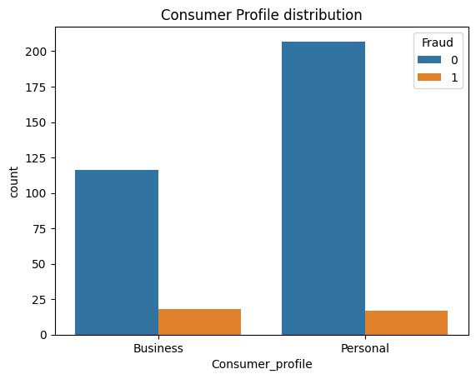

From this graph, it is clear that majority of the claims are from consumer who purchased the products for personal use. However,the consumers who purchases the products for business purpose have higher number of fraudulent warranty claims.

## Product and Fraudulent Claims

|  |
| --- |
| sns**.**histplot(x **=** 'Product_type', data **=** df, hue **=** 'Fraud', multiple**=**'stack')**.**set |

In [ ]:

Out[ ]: Text(0.5, 1.0, 'Product and Fraud Distribution')

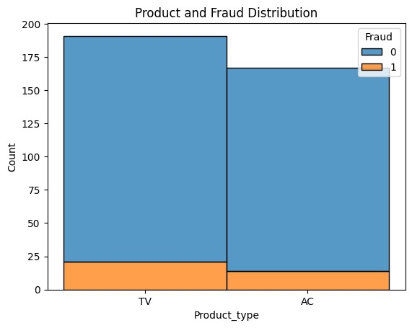

This graph shows that the company has higher sales for the TV as compared to the AC, and ultimately the number warranty claims for TV is higher than AC. Moreover, the number of fraudulent claims for TV is also higher than AC.

**Issue with the Product Parts and Fraudulent Claims**

|  |
| --- |
| fig, ax **=** plt**.**subplots(2,3,figsize**=**(20,12))  sns**.**histplot(x **=** 'AC_1001_Issue', data **=** df, ax **=**ax[0,0], hue **=** 'Fraud', multipl sns**.**histplot(x **=** 'AC_1002_Issue', data **=** df, ax **=**ax[0,1], hue **=** 'Fraud', multipl sns**.**histplot(x **=** 'AC_1003_Issue', data **=** df, ax **=**ax[0,2], hue **=** 'Fraud', multipl sns**.**histplot(x **=** 'TV_2001_Issue', data **=** df, ax **=**ax[1,0], hue **=** 'Fraud', multipl sns**.**histplot(x **=** 'TV_2002_Issue', data **=** df, ax **=**ax[1,1], hue **=** 'Fraud', multipl sns**.**histplot(x **=** 'TV_2003_Issue', data **=** df, ax **=**ax[1,2], hue **=** 'Fraud', multipl |

In [ ]:

Out[ ]: [Text(0.5, 1.0, 'TV_2003_Issue and Fraud Distribution')]

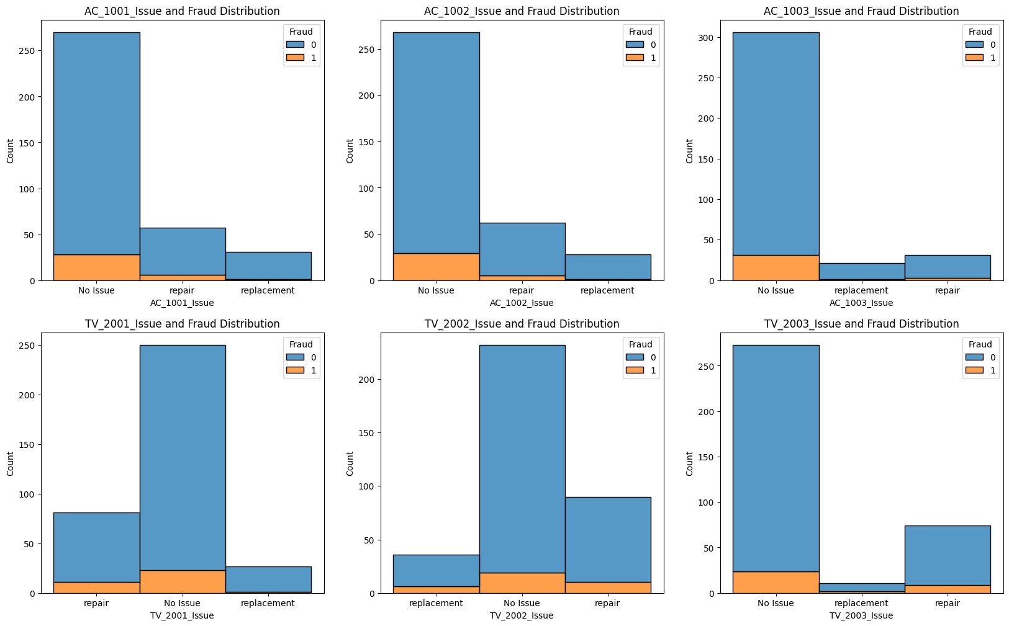

The above graphs visualizes the issue with the product parts and fradulent warranty claims on them. In the product AC the parts AC_1001 and AC_1002 has increases number of repairs whereas as the AC_1003 has considerable less instances of repair or replacement as compared to other two, so the company should focus on improving the AC_1001 and AC_1002 parts. Moreover, in all three parts, fradulent claims usually occurs when there is no issue with the product.

In the product TV the parts TV_2001 and TV_2002 has increases number of repairs whereas as the TV_1003 has considerable less instances of repair and negligible instances of replacement as compared to other two, however in contrast to AC, the fradulent claims usually occurs when there is issue with the product as well as when the product parts especially TV_2001 and TV_2002 requires repair or replacement. So the company should focus on improving the TV_2001 and TV_2002 parts, in order to reduce the number of fradulent claims.

## Service Center and Fraudulent Claims

In [ ]: sns**.**countplot(x **=** 'Service_Centre', data **=** df, hue **=** 'Fraud')**.**set_title('Service

Out[ ]: Text(0.5, 1.0, 'Service Centre and Fraudulent Claims')

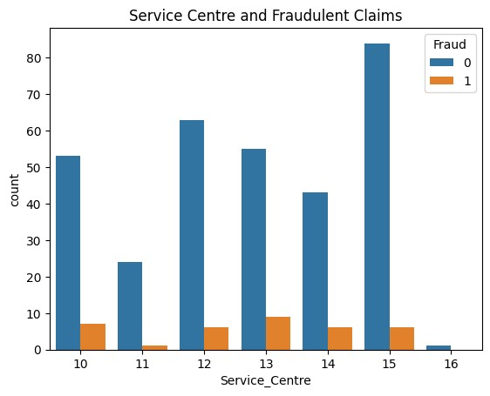

This graoh shows the relation between the relationship between the service centre and the fraudulent warranty claims. The majorty of the replairs and replacements are done by the service centre 15,12 and 13. Where, the service centre 13 has the highest number of fradulent claims, followed by service centre 10. So, the company should survelliance the service centre 13 and 10 more closely.

## Claim Value and Fraudulent Claims

In [ ]: fig, ax **=** plt**.**subplots(1,2,figsize**=**(15,5)) sns**.**boxplot(x **=** 'Fraud', y **=** 'Claim_Value', data **=** df, ax **=**ax[0])**.**set_title('Cla sns**.**violinplot(x **=** 'Fraud', y **=** 'Claim_Value', data **=** df, ax **=**ax[1])**.**set_title('

Out[ ]: Text(0.5, 1.0, 'Claim Value and Fraudulent Claims')

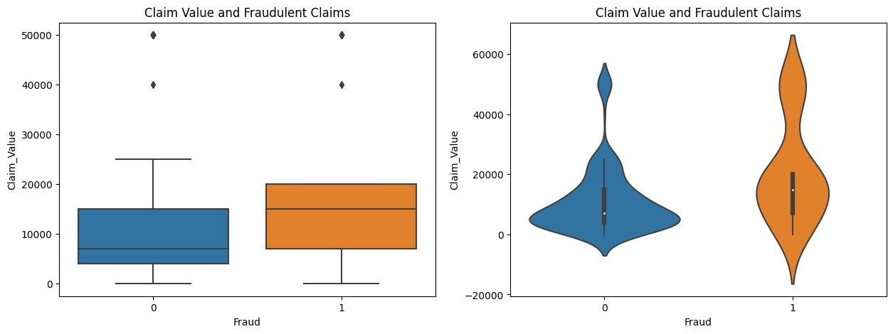

As expected, these graphs shows that the claim value for fradulent clains tends to be higher than the genuine claims. In the boxplot, the medianclaim value of fraudulent claims is way higher than the genuine claims. In addtion to that, it is clear form the boxplot that the fraudulent claims are more spread out at higher claim values than the genuine claims.

## Product Age and Fraudulent Claims

In [ ]: sns**.**histplot(x **=** 'Product_Age', data **=** df, hue **=** 'Fraud', multiple**=**'stack', bins

Out[ ]: Text(0.5, 1.0, 'Product Age(in days) and Fraud Distribution')

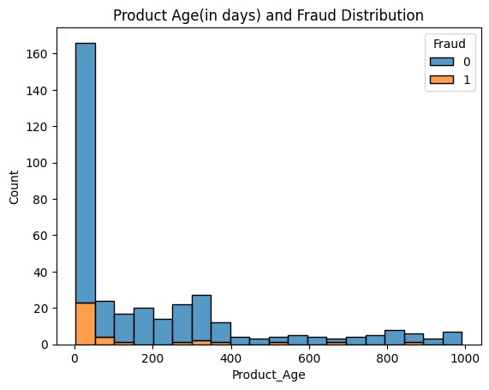

From the above histogram, it is clear that majority of the warranty claims occur within 100 days of purchase. However, the fraudulent claims are more frequent and they usually occur within 50 days of purchase.

## Purchase point and Fraudulent Claims

|  |
| --- |
| sns**.**histplot(x **=** 'Purchased_from', data **=** df, hue **=** 'Fraud', multiple**=**'stack')**.** |

In [ ]:s

Out[ ]: Text(0.5, 1.0, 'Purchased from and Fraudulent Claims')

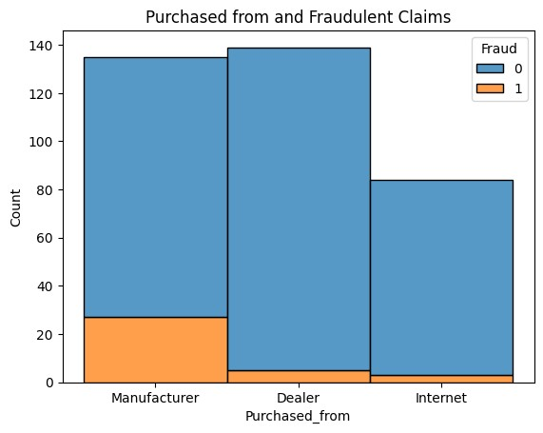

Maximum number of purchase is done through the dealer, but the maximum number of fraudulent claims are coming when the purchase is done through the manufacturer, whereas the internet has the lowest number of fraudulent claims. This much fradulent claims only from the manufacturer is a matter of concern for the company.

## Call Duration and Fraudulent Claims

|  |
| --- |
| sns**.**histplot(x **=** 'Call_details', data **=** df, hue **=** 'Fraud', multiple**=**'stack')**.**set plt**.**xlabel('Call Duration(in mins)') |

In [ ]:

Out[ ]: Text(0.5, 0, 'Call Duration(in mins)')

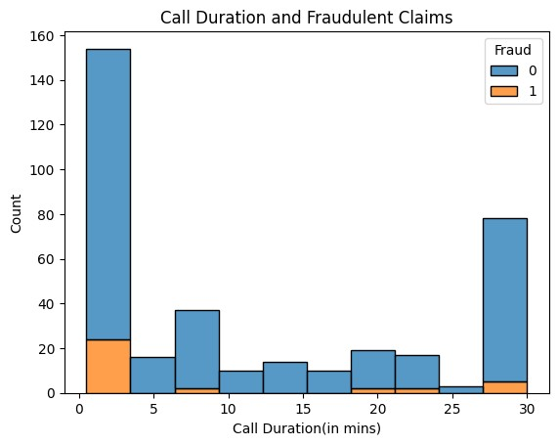

This graph shows the relation of customer care call duration and the fraudulent claims. In order to make a warranty claims, customers contact the customer care. The duration of customer care calls are plotted in the histogram along with the authenciity of the claims. The histogram shows that the fraudulent claims are more frequent when the customer care call duration is less than 3-4 minutes. However, the genuine claims are more frequent when the customer care call duration is more than 4 minutes.

## Purpose of contact and Fraudulent Claims

In [ ]: sns**.**histplot(x **=** 'Purpose', data **=** df, hue **=** 'Fraud', multiple**=**'stack')**.**set_titl

Out[ ]: Text(0.5, 1.0, 'Purpose and Fraudulent Claims')

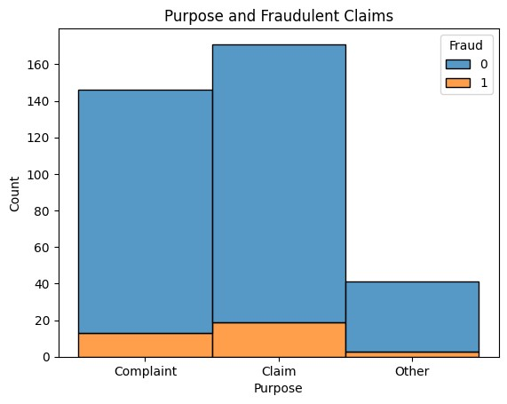

Most of the customer contact the customer care for the purpose of complaint and claim and very few with other reasons. However, the fraudulent claims are more frequent when the customer contact the customer care for the purpose of complaint and claim.

# Data Preprocessing Part 2

## Outlier Removal

|  |
| --- |
| *# Removing outliners from claim value column using IQR method*  Q1 **=** df['Claim_Value']**.**quantile(0.25)  Q3 **=** df['Claim_Value']**.**quantile(0.75) IQR **=** Q3 **-** Q1 df **=** df[**~**((df['Claim_Value'] **<** (Q1 **-** 1.5 **\*** IQR)) **|**(df['Claim_Value'] **>** (Q3 **+** 1.5 |

In [ ]:

## Label Encoding the Object Datatypes

|  |
| --- |
| **from** sklearn.preprocessing **import** LabelEncoder  *#Label encoding Object* le **=** LabelEncoder()  *# columns for label encoding*  cols **=** df**.**select_dtypes(include**=**['object'])**.**columns |

In [ ]:

*# label encoding* **for** col **in** cols: le**.**fit(df[col]) df[col] **=** le**.**transform(df[col]) print(col, df[col]**.**unique())

Region [4 1 2 3 5 6 7 0]

State [10 6 16 9 11 0 2 5 3 13 19 4 8 1 15 12 18 17 7 14]

Area [1 0] City [ 2 5 6 21 11 9 18 20 24 16 15 1 19 12 26 17 23 8 10 3 14 7 0 22 4 25 13]

Consumer_profile [0 1]

Product_category [0 1]

Product_type [1 0]

AC_1001_Issue [0 1 2]

AC_1002_Issue [0 1 2]

AC_1003_Issue [0 2 1]

TV_2001_Issue [1 0 2]

TV_2002_Issue [2 0 1]

TV_2003_Issue [0 2 1]

Purchased_from [2 0 1]

Purpose [1 0 2]

# Correlation Matrix Heatmap

|  |
| --- |
| plt**.**figure(figsize**=**(15,10))  sns**.**heatmap(df**.**corr(), annot**=True**, cmap**=**'coolwarm') |

In [ ]:

Out[ ]: <Axes: >

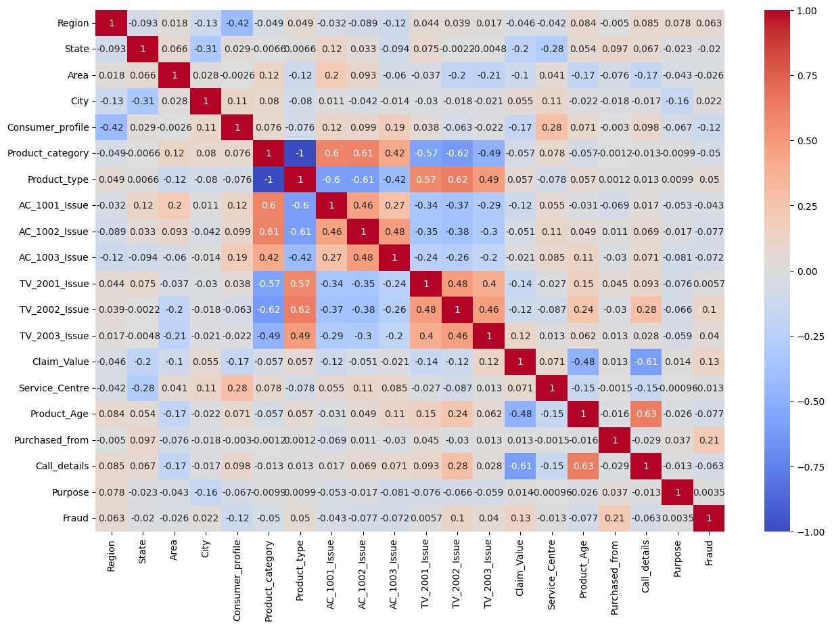

# Train Test Split

In [ ]: **from** sklearn.model_selection **import** train_test_split

X_train, X_test, y_train, y_test **=** train_test_split(df**.**drop('Fraud',axis**=**1), df[

# Model Building

I will be using the following classification models:

Decision Tree Classifier

Random Forest Classifier

Logistic Regression

## Decision Tree Classifier

|  |
| --- |
| **from** sklearn.tree **import** DecisionTreeClassifier  *#Decision Tree Classifier Object* dtree **=** DecisionTreeClassifier() |

In [ ]:

Hyperparameter Tuning using GridSearchCV

|  |
| --- |
| **from** sklearn.model_selection **import** GridSearchCV  *#parameters for grid search* param_grid **=** {  'max_depth': [2,4,6,8,10],  'min_samples_leaf': [2,4,6,8,10],  'min_samples_split': [2,4,6,8,10],  'criterion': ['gini', 'entropy'],  'random_state': [0,42]  }  *#Grid Search Object with Decision Tree Classifier*  grid **=** GridSearchCV(dtree, param_grid, cv**=**5, verbose**=**1, n_jobs**=-**1, scoring**=**'accu  *#Fitting the grid search object to the training data* grid**.**fit(X_train,y_train)  *#Best parameters for Decision Tree Classifier* print(grid**.**best_params_) |

In [ ]:

Fitting 5 folds for each of 500 candidates, totalling 2500 fits

{'criterion': 'gini', 'max_depth': 2, 'min_samples_leaf': 2, 'min_samples_split':

2, 'random_state': 0}

In [ ]:

|  |
| --- |
| *#Best estimator for Decision Tree Classifier*  dtree **=** DecisionTreeClassifier(criterion**=**'gini', max_depth**=**4, min_samples_leaf**=**  *#Fitting the Decision Tree Classifier to the training data* dtree**.**fit(X_train,y_train)  *#training accuracy*  print(dtree**.**score(X_train,y_train))  *#prediction on test data* d_pred **=** dtree**.**predict(X_test) |

2

0.9313304721030042

## Random Forest Classifier

|  |
| --- |
| **from** sklearn.ensemble **import** RandomForestClassifier  *#Random Forest Classifier Object* rfc **=** RandomForestClassifier() |

In [ ]:

Hyperparameter Tuning using GridSearchCV

|  |
| --- |
| **from** sklearn.model_selection **import** GridSearchCV  *#parameters for grid search* param_grid **=** {  'max_depth': [2,4,6,8],  'min_samples_leaf': [2,4,6,8],  'min_samples_split': [2,4,6,8],  'criterion': ['gini', 'entropy'],  'random_state': [0,42]  }  *#Grid Search Object with Random Forest Classifier*  grid **=** GridSearchCV(rfc, param_grid, cv**=**5, verbose**=**1, n_jobs**=-**1, scoring**=**'accura  *#Fitting the grid search object to the training data* grid**.**fit(X_train,y_train)  *#Best parameters for Random Forest Classifier* print(grid**.**best_params_) |

In [ ]:

Fitting 5 folds for each of 256 candidates, totalling 1280 fits

{'criterion': 'gini', 'max_depth': 2, 'min_samples_leaf': 2, 'min_samples_split':

2, 'random_state': 0}

|  |
| --- |
| *#random forest classifier with best parameters*  rfc **=** RandomForestClassifier(criterion**=**'gini', max_depth**=**2, min_samples_leaf**=**2,  *#Fitting the Random Forest Classifier to the training data* rfc**.**fit(X_train,y_train)  *#training accuracy*  print(rfc**.**score(X_train,y_train))  *#prediction on test data* r_pred **=** rfc**.**predict(X_test) |

In [ ]:

0.9184549356223176

## Logistic Regression

|  |
| --- |
| **from** sklearn.linear_model **import** LogisticRegression  *#Logistic Regression Object* lr **=** LogisticRegression()  *#Fitting the Logistic Regression to the training data* lr**.**fit(X_train,y_train) |

In [ ]:

|  |
| --- |
| *#training accuracy*  print(lr**.**score(X_train,y_train))  *#prediction on test data* l_pred **=** lr**.**predict(X_test) |

0.9184549356223176

# Model Evaluation

## Confusion Matrix Heatmap

In [ ]:

|  |
| --- |
| fig, ax **=** plt**.**subplots(1,3,figsize**=**(20,5)) **from** sklearn.metrics **import** confusion_matrix  *#confusion matrix for Decision Tree Classifier*  sns**.**heatmap(confusion_matrix(y_test,d_pred), annot**=True**, cmap**=**'coolwarm', ax**=**ax  *#confusion matrix for Random Forest Classifier*  sns**.**heatmap(confusion_matrix(y_test,r_pred), annot**=True**, cmap**=**'coolwarm', ax**=**ax  *#confusion matrix for Logistic Regression*  sns**.**heatmap(confusion_matrix(y_test,l_pred), annot**=True**, cmap**=**'coolwarm', ax**=**ax |

[

[

[

Out[ ]: Text(0.5, 1.0, 'Logistic Regression')

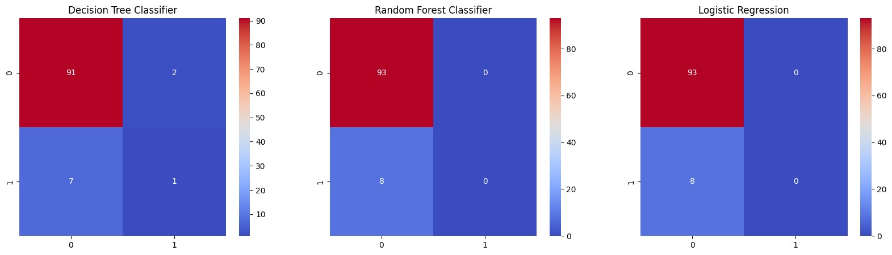

## Classification Report

|  |
| --- |
| **from** sklearn.metrics **import** classification_report  *#classification report for Decision Tree Classifier* print(classification_report(y_test,d_pred))  *#classification report for Random Forest Classifier* print(classification_report(y_test,r_pred))  *#classification report for Logistic Regression* print(classification_report(y_test,l_pred)) |

In [ ]:

precision recall f1-score support

0 0.93 0.98 0.95 93 1 0.33 0.12 0.18 8

accuracy 0.91 101 macro avg 0.63 0.55 0.57 101 weighted avg 0.88 0.91 0.89 101 precision recall f1-score support

0 0.92 1.00 0.96 93 1 0.00 0.00 0.00 8

accuracy 0.92 101 macro avg 0.46 0.50 0.48 101 weighted avg 0.85 0.92 0.88 101 precision recall f1-score support

0 0.92 1.00 0.96 93 1 0.00 0.00 0.00 8

accuracy 0.92 101 macro avg 0.46 0.50 0.48 101 weighted avg 0.85 0.92 0.88 101

|  |
| --- |
| **from** sklearn.metrics **import** accuracy_score, r2_score, mean_squared_error  print('==================== Decision Tree Classifier ====================') print('Accuracy Score: ', accuracy_score(y_test,d_pred)) print('R2 Score: ', r2_score(y_test,d_pred))  print('Mean Squared Error: ', mean_squared_error(y_test,d_pred))  print('==================== Random Forest Classifier ====================') print('Accuracy Score: ', accuracy_score(y_test,r_pred)) print('R2 Score: ', r2_score(y_test,r_pred))  print('Mean Squared Error: ', mean_squared_error(y_test,r_pred))  print('==================== Logistic Regression =========================') print('Accuracy Score: ', accuracy_score(y_test,l_pred)) print('R2 Score: ', r2_score(y_test,l_pred)) print('Mean Squared Error: ', mean_squared_error(y_test,l_pred)) |

In [ ]:

==================== Decision Tree Classifier ====================

Accuracy Score: 0.9108910891089109

R2 Score: -0.2217741935483868

Mean Squared Error: 0.0891089108910891 ==================== Random Forest Classifier ====================

Accuracy Score: 0.9207920792079208

R2 Score: -0.08602150537634379

Mean Squared Error: 0.07920792079207921 ==================== Logistic Regression =========================

Accuracy Score: 0.9207920792079208

R2 Score: -0.08602150537634379

Mean Squared Error: 0.07920792079207921

# Feature Importance

|  |
| --- |
| *#feature importance for Decision Tree Classifier*  feature_importance_d **=** pd**.**DataFrame(dtree**.**feature_importances_, index**=**X_train**.**co  *#feature importance for Random Forest Classifier*  feature_importance_r **=** pd**.**DataFrame(rfc**.**feature_importances_, index**=**X_train**.**colu  fig, ax **=** plt**.**subplots(1,2,figsize**=**(20,5))  *#space between subplots* fig**.**subplots_adjust(wspace**=**0.5) sns**.**barplot(y**=**feature_importance_d**.**index, x**=**feature_importance_d['Feature Import ax[0]**.**xaxis**.**set_tick_params(rotation**=**90) sns**.**barplot(y**=**feature_importance_r**.**index, x**=**feature_importance_r['Feature Import ax[1]**.**xaxis**.**set_tick_params(rotation**=**90) |

In [ ]:

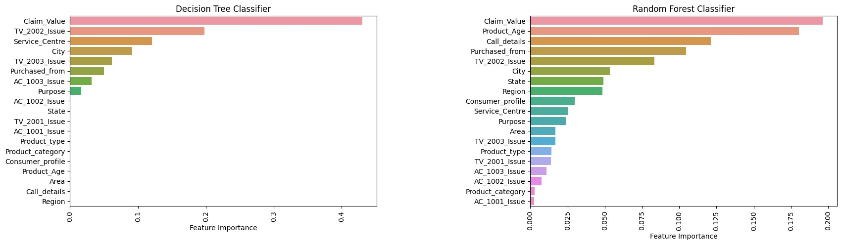

# Conclusion

From the exploratory data analysis, I have concluded that most of the warranty claims takes place in the southern region of India particularly in Andhra Pradesh and Tamil Nadu. Moreover, the fraudulent claims are more frequent in the cities like Hyderabad and Chennai whih are urban regions. The dataset includes the claims regarding two products i.e. TV and AC. The TVs had the higher warranty claims when they where purchased for personal purposes as compared to AC.

Moreover, in the case of Ac the fraudulent claims were made, when there was no issue in the AC parts. However, in the case of TV the fraudulent claims were made, when there was issue in the TV parts as well as when there was no issue in the TV parts. The fraudulent claims were more frequent when the purchase was made through the manufacturer.

The fraudulent claims tend to have higher claim value as compared to the genuine ones, and the service centre 13 had the highest number of fraudulent claims despite of having lesser number of total warranty claims. It was also observed that the fraudulent claims were more frequent when the customer care call duration was less than 3-4 minutes.

Coming to the machine learning models, I have used Decision Tree Classifier, Random

Forest Classifier and Logistic Regression. All these models gave excellent accuracy of 91-

92%. However, due to lesser number of fraudulent claims or small dataset size, the

models have poor recall score for fraudulent claims. But this issue can be resolved by collecting more data.